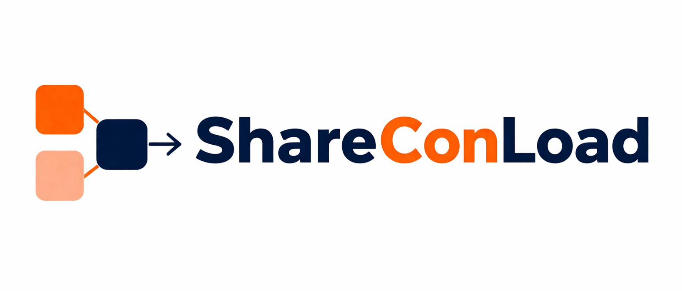
PRIVACY POLICY
ShareConLoad Digital Logistics Marketplace
Effective Date: 09 May 2026
This Privacy Policy explains how VEYQON GROUP (Pty) Ltd, registration number 2026/353683/07 ("ShareConLoad", "we", "us", or "our"), collects, uses, stores, processes, and protects personal information through the ShareConLoad platform and related services.

ShareConLoad is committed to protecting user privacy and processing personal information responsibly in accordance with applicable laws, including the Protection of Personal Information Act, 2013 ("POPIA") of South Africa.

By accessing or using the Platform, you consent to the practices described in this Privacy Policy.

1. ABOUT SHARECONLOAD
ShareConLoad is a digital logistics marketplace platform operated by VEYQON GROUP (Pty) Ltd.

The Platform facilitates shipment booking and payment coordination between cargo owners and independent transport operators for international maritime shared-container shipping services.

2. INFORMATION WE COLLECT
We may collect and process the following categories of personal information:

2.1 Customer Information
▸ Full names
▸ Company names
▸ Email addresses
▸ Telephone numbers
▸ Billing information
▸ Shipment information
▸ Cargo details
▸ Customs documentation
▸ Import/export documentation
▸ Account credentials
▸ Communication records
▸ Transaction history

2.2 Operator Information
▸ Company registration details
▸ Business contact information
▸ Banking details
▸ Tax information
▸ Operational licenses
▸ Permits and certifications
▸ Insurance documentation
▸ Shipment performance information
▸ Compliance records

2.3 Technical Information
We may automatically collect technical and usage information, including:
▸ IP addresses
▸ Browser type
▸ Operating system
▸ Device information
▸ Login timestamps
▸ Platform activity
▸ Cookies and session data
▸ Analytics and performance information

3. HOW WE COLLECT INFORMATION
Information may be collected through:
▸ Account registration
▸ Booking submissions
▸ Payment processing
▸ Customer support interactions
▸ Uploaded documents
▸ Website usage
▸ Cookies and analytics technologies
▸ Communications with Operators and Customers

4. HOW WE USE INFORMATION
We use personal information to:
▸ Facilitate shipment bookings
▸ Process payments
▸ Verify users and Operators
▸ Coordinate shipment activities
▸ Communicate operational updates
▸ Manage disputes and claims
▸ Comply with legal obligations
▸ Improve platform functionality
▸ Detect fraud or suspicious activity
▸ Maintain operational security
▸ Provide customer support
▸ Send service-related notifications

Where users consent, we may also send:
▸ Promotional communications
▸ Product updates
▸ Marketing information

Users may opt out of marketing communications at any time.

5. PAYMENT PROCESSING
Payments are processed through authorized third-party payment providers, including PayStack.

ShareConLoad does not store full payment card details directly unless expressly stated otherwise.

Payment information may be subject to the privacy and security policies of third-party payment providers.

6. SHARING OF INFORMATION
We may share information with:
▸ Independent Operators and Carriers
▸ Payment service providers
▸ Customs and regulatory authorities
▸ Logistics and operational partners
▸ Cloud hosting and technology providers
▸ Legal and compliance advisors
▸ Law enforcement or government authorities where legally required

Information is shared only where reasonably necessary for operational, legal, compliance, or security purposes.

7. INTERNATIONAL DATA TRANSFERS
Because ShareConLoad operates internationally, personal information may be processed, transferred, or stored outside South Africa through third-party service providers and cloud infrastructure providers.

By using the Platform, users consent to such international transfers where necessary for service delivery and operational purposes.

8. DATA RETENTION
ShareConLoad retains personal information only for as long as reasonably necessary to:
▸ Provide services
▸ Comply with legal obligations
▸ Resolve disputes
▸ Enforce agreements
▸ Maintain operational records
▸ Protect legitimate business interests

Certain information may be retained longer where required by law or regulatory obligations.

9. USER RIGHTS
Subject to applicable laws, users may request to:
▸ Access their personal information
▸ Correct inaccurate information
▸ Update account information
▸ Request deletion of personal information where legally permissible
▸ Object to certain processing activities
▸ Withdraw consent where applicable

Requests may be submitted to: support@shareconload.com

ShareConLoad may require reasonable identity verification before processing requests.

10. COOKIES AND TRACKING TECHNOLOGIES
ShareConLoad may use the following technologies:
▸ Cookies
▸ Session tracking
▸ Analytics tools
▸ Similar tracking technologies

These technologies are used to:
▸ Improve platform performance
▸ Maintain user sessions
▸ Analyze usage patterns
▸ Enhance security
▸ Improve user experience

Users may disable cookies through browser settings, although some platform functionality may be affected.

11. DATA SECURITY
ShareConLoad implements reasonable technical and organizational security measures to protect personal information against:
▸ Unauthorized access
▸ Misuse
▸ Loss
▸ Disclosure
▸ Alteration
▸ Destruction

Despite reasonable safeguards, no internet-based system can be guaranteed completely secure.

Users are responsible for maintaining the confidentiality of their account credentials.

12. OPERATOR AND THIRD-PARTY RESPONSIBILITY
Operators and third-party service providers may independently process personal information in connection with shipment execution and operational services.

ShareConLoad is not responsible for the privacy practices of independent third parties.

Users are encouraged to review third-party privacy policies where applicable.

13. CHILDREN AND MINORS
The Platform is not intended for individuals under the age of 18 years.

ShareConLoad does not knowingly collect personal information from minors.

If we become aware that information relating to a minor has been submitted, such information may be removed.

14. LEGAL DISCLOSURES
ShareConLoad may disclose personal information:
▸ Where required by law
▸ In response to lawful regulatory requests
▸ To protect legal rights
▸ To investigate fraud or unlawful conduct
▸ To protect platform security and operational integrity

15. CHANGES TO THIS PRIVACY POLICY
ShareConLoad reserves the right to update or amend this Privacy Policy from time to time.

Updated versions become effective upon publication on the Platform.

Continued use of the Platform constitutes acceptance of revised policies.

16. CONTACT INFORMATION
VEYQON GROUP (Pty) Ltd
Registration Number: 2026/353683/07
Republic of South Africa
Website: shareconload.com
Email: support@shareconload.com

Share the Load. Connect the World.

